Installing an Air Source Heat Pump (ASHP)
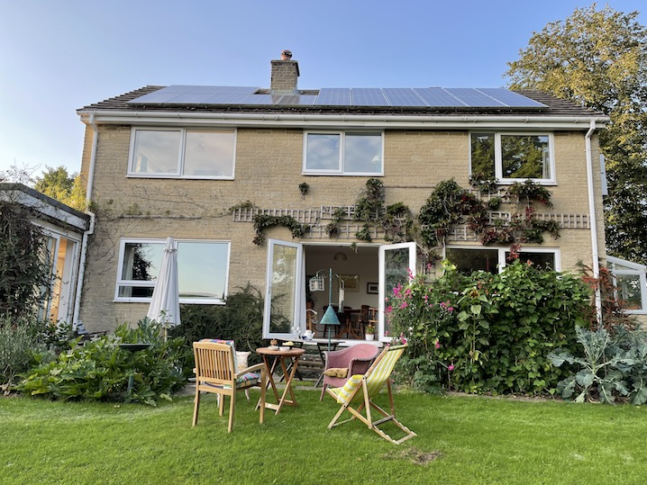

The Context
We live in a 1970s four bedroom detached house in Hathersage. For environmental reasons, we converted from a gas hob and gas CH to an ASHP and electrical induction hob, thus disconnecting from mains gas. A generous government allowance towards the costs helped.
Below are some of the benefits and potential and actual problems with the project.

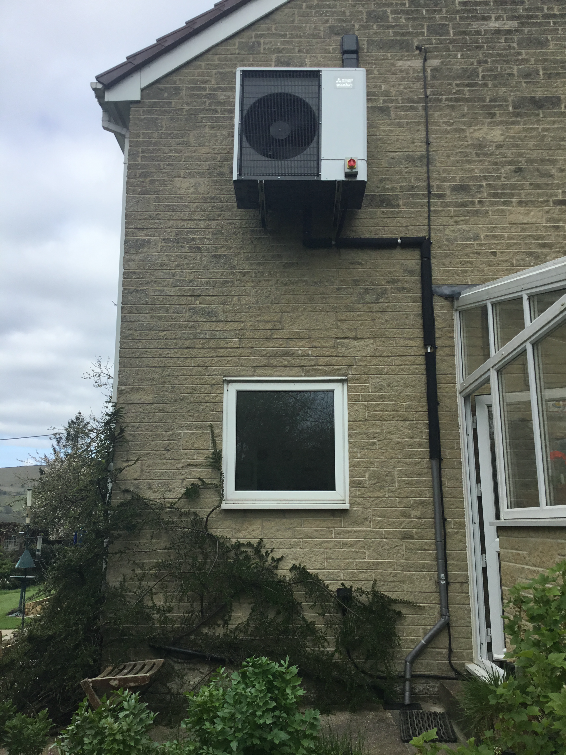
The ASHP

In February 2020 a Mitsubishi Ecodan 11.2kW unit was installed. The installer* told us installation would be 1 or 2 days. It took 3 days during snowy weather, without heating or hot water and fitters who never closed doors. The plumbing was appalling, eg leaks in 4 radiator connections. We should have done more research before trusting this company*.

Quality of heating
The system normally runs at 50degC, considerably less than most gas systems. Radiators and water are therefore less hot and the heating is on for much longer. Air temperature increase is less than one degree per hour and input power is usually no more than 3kW.
After experimenting with the timing programmer, a more even warmth is provided with fewer cold spots. A wood burning stove lit each evening enabled us to turn the heating down. The system provides adequate heating, but its slow response means it’s perhaps better as background heating.

Overall Costs and benefits
At an installed cost of £15,000 (including replacing most radiators) the system was calculated (at 2020 fuel prices) to save £127 on the costs of £1,800 with an ageing gas fired system. Costs have now greatly increased. Such calculations (made prior to installation) are based on considerably warmer standardised heating levels in living areas (25degC ) than we set ourselves (18degC), and standardised climate assumptions.
In practice, in the last year our ASHP has consumed 4200kWH, 80%on space heating, 20% on hot water. This would have cost us £1500 at prices from April 2022.
Over these first 2 years, ASHP system running costs are not very different from our previous gas system. Since installation costs were refunded over 7 years through the government’s RHI payments scheme, the whole project is cost neutral. However, gas boilers will become redundant in due course.
Actual costs depend very much upon insulation and efficiency.

Insulation
Prior to fitting, the government’s RHI repayments scheme required a house survey to determine heating requirements, and thus the carbon footprint reduction the ASHP would achieve. Our rating was level 69, just in Category C. Certain bodies only recommend an ASHP for properties rated C or above. However, after installation we added further insulation to two ceilings which bore directly onto external roofs above, thus improving the rating. Had we not hurried in order to gain the government grant within its time frame, we’d have done this before fitting, and also considered more carefully where to site the ASHP and associated hot water cylinder.

Siting of ASHP
ASHP are noisy. Our system (Ecodan, by Mitsubishi) claims to be one of the quietest. But I wouldn’t like it attached outside my bedroom wall.
The hot water cylinder is in the attic, very near the ASHP (less pipework and heat loss), and also relieving space within the house. However, this increased the length of pipe between cylinder and hot taps throughout the house, increasing heat loss and reducing tap water temperature. Heat is lost from the cylinder and pipes to the cold attic, instead of to an airing cupboard.
In retrospect I should have given more thought to these issues before installation, and the installers were of little help.

Using ASHP with Solar pvPanels
We already had solar panels before ASHP installation. And a Solar Boost which directed unused solar power into the hot water cylinder, rather than back to the grid. However, only after 2 years were the installers* able to fit a Solar iBoost. We expect this now to heat about a third of our hot water, saving about £100 a year, repaying the iBoost cost over 3 years.

Efficiency
ASHPs are generally said to provide a Coefficient of Performance (COP) of around 3 (ie. 1kW of input provides 3kW of heat output). However our average COP is around 2.8 for heating and 1.8 for hot water.

The COP is less at lower outside temperatures and higher if the hot water temperature of the system is reduced still further (reducing heat output).

Leaking radiators reduced their water pressure, lowering efficiency. I regularly increase water pressure when necessary. This otherwise would have been checked only at annual service, thereby increasing heating bills.

Installers programmed the system in ways uneconomical for us. I have figured out how to do it in order to maximise economy and convenience.

As protection against Legionnaires Disease, an immersion heater (much more expensive to run than the ASHP) heats the hot water cylinder to 65degC. Installers programmed it to operate weekly: I reset this to once a month. You might need to check local regulations.

Conclusions
An ASHP may or may not be a good idea depending on your house. For me, the cost of heating is slightly less and the quality of heating is more comfortable than our previous gas boiler. As alternative energy sources become more abundant, the cost advantage of ASHP is likely to increase as electricity becomes cheaper relative to gas.

ASHPs are complicated! Especially the technical details. It’s been worthwhile to learn a bit, rather than rely on annual services: this would have cost more.

And finally, try to find an installer with positive recommendations.
A good summary of the issues involved can be found at:

https://www.homebuilding.co.uk/advice/heat-pump-vs-gas-boiler

Do get in touch with us to discuss any aspect, or to see our system.

Stephen Rowland and Gillie Bolton
Email: stephen.cw.rowland@btinternet.com
gillie@gilliebolton.com

* I have not named the installation company here. If you would like to get in touch with me I can give more details

