Hope Valley Climate Action Strategy
Jeremy Wight, July 17th 2021

Context
The climate crisis is the biggest challenge currently facing human society. Arguably, it is the biggest challenge human society has faced for centuries. The best estimate we have of carbon emissions arising from household consumption are from a UK study by Exeter University. This gives an average household carbon footprint of 21 tonnes. To match the UK Government's commitments we need to half average household emissions to 10 tonnes by 2030 and to 4 tonnes by 2050.
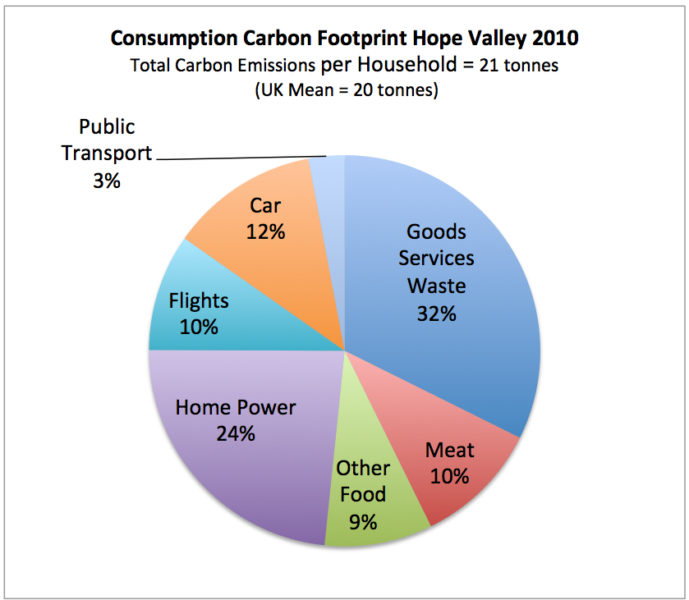

Where we are now
Over the past two years, HVCA has grown and developed. We established decentralised structure, with Action and Village groups, became a Charitable Incorporated Organisation (CIO) in 2020, built a supporter base of over 600 people, and have four part time staff.
We are recognised as a credible organization, with good expertise on climate change. We have built up a working relationship with local politicians, and major local employers. We have two projects (Renewable Energy Feasibility and Travelling Light) with paid project officers.

Where we want to get to - OUTCOMES
We have a vision of the Valley being more sustainable, less polluted and with quieter roads. There will be a greater sense of community and self-reliance, better transport, a healthier diet and lower energy bills. We want to make a difference locally as well as nationally, and to add to the wider debate about our response to the climate emergency. And we want to demonstrate that a step-change to a lower-carbon, future with greater bio-diversity is possible and desirable in:

Travel and transport
By 2030 CO2 emissions from transport will have been reduced dramatically because many more local people and visitors walk and cycle for everyday short journeys, use high quality, integrated rail and bus services, and have switched to electric vehicles which they use selectively and on a shared basis. The tranquil Valley has become a national exemplar of sustainable travel, benefiting local people and the visitor economy.

Home energy efficiency
The energy efficiency of our homes will need to have been improved dramatically by 2030. The majority of homes (90% or more) will have an energy rating of C or better This will have involved insulating walls roofs and floors to current building regulation standards or better installing high performance double glazing and making homes fairly air-tight.

Renewable energy generation
All homes will buy their electricity from a genuinely green supplier and over a quarter of the domestic electricity demand in the Valley will be generated locally from renewable sources of wind and solar. Large scale battery, pumped storage and electric vehicles will be used to help manage peak demand.

Farming, Land management and restoriung nature for bio-diversity
We will have greater positive engagement with farmers and land owners. The Environment Land Management Scheme (ELMS) will be fully operational and farming and land will be managed more sustainably to increase bio-diversity and capture more carbon. Peat bogs will have been restored, trees will have been planted were appropriate and bio-diverse meadows will have been cherished and protected.

How we are going to get there
Hope Valley Climate Action was established to address this by working in three ways:

Raising local awareness

Local action to reduce greenhouse gas emissions

Advocating for policies at all levels that address the climate emergency.
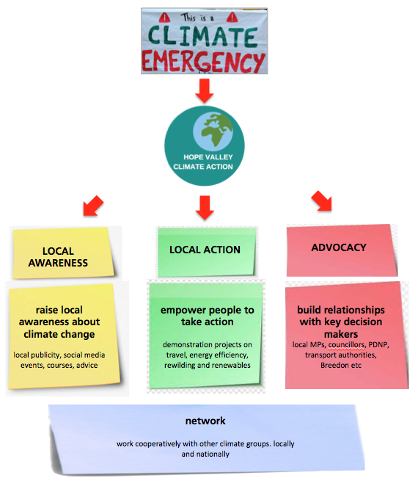
Local Awareness
We want to consolidate our position as an effective, respected, campaigning organization, and to have brought about a step change in local awareness about climate change and its impacts. We need to continue to build our large and thriving supporter base at local level and to establish ourselves as the ‘go to’ place in the Valley for information and advice about the climate.
Local Action
Through our action and village groups we want to demonstrate locally what can be done in terms of reducing GHG emissions and that can be emulated elsewhere. We need to show that we are engaged with, and speaking for, the whole population. In particular this means engaging with the agricultural community, and people across the socio-economic spectrum, as well as children and young people.
Advocacy
We want to develop our advocacy, both in terms of capacity and content. This means both having a clear set of ‘asks’ and the communication channels necessary to bring these to the attention of policy makers. We need to develop strong links with other organisations locally and nationally to make our voice louder.

10 Point Action plan
We need to:
- (Continue to) raise awareness about climate change locally by promoting carbon literacy and similar courses, seeking as much local publicity as possible and running local events.
- Refresh and expand our communications, including in particular the use of social media
- Encourage and support local action and village groups
- Establish / encourage the establishment of action groups relating to agriculture and land management, and children, young people and education
- Continue to build and nurture relationships with key decision makers and influencers.
- Refocus on advocacy and engagement with policy makers, using the forthcoming COP26 as an immediate platform
- Make the link between local action and advocacy more transparent and explicit.
- Seek out and work with our allies, both locally and nationally.
- Undertake a formal analysis of the HV carbon footprint, and set out some proposed pathways, with timescales to net zero.
- Link our advocacy to key events over the period of this strategy, including COP-26 in November 2021, likely General Election in 2023, local elections, etc.

https://impact-tool.org.uk/static/doc/Impact-methodology-paper-v1.6.pdf

